CBETA
Contributions to Beam Position Measurement Errors and a Plan to Provide Measurements with Sufficient Accuracy
R. Michnoff, J. Dobbins, R. Hulsart, Dragana Jusic, Y. Li
October 20, 2017

Introduction

The purpose of this document is to provide a list of known contributions to beam position measurement errors and to define a plan to provide the best possible measurement accuracy, including surveying and electronic calibration.

Absolute Position vs. Relative Position

Absolute position measurement accuracy must be distinguished from relative position accuracy. Relative accuracy is the smallest step size that can be measured when beam is moved from one position to another, and absolute accuracy is the offset of the reported position measurement from the actual beam position, where absolute position 0 is typically the mechanical center of the beam position monitor (BPM) chamber.

Past experience has shown that while relative beam position changes can be detected at the several micron to sub micron level with presently available BPM hardware, absolute position is much more difficult to determine and is often accurate to only within about 100-200 microns.

This document will focus primarily on the items that contribute to absolute position errors.

Precision of difference orbits

High quality difference orbits are important for CBETA, in particular for measuring dispersion, optical functions, beam response to corrector coils, etc. Providing difference orbit measurements is essentially a relative position measurement – that is, measuring position, making a machine change, and measuring the position change. This is considered to be a relative beam position measurement as described above, and relative beam position changes are expected to be accurate to about several micrometers or better, assuming good averaging of the measurements.

Contributions to absolute position errors

The following table provides a list of the known contributions to absolute position measurement errors. The combined effective absolute position error is expected to be about 300 micrometers or more.

 | Description | Approx. Error (um)
1. | Mechanical offset of buttons in BPM chamber | 200+
1.1 | Distance of the button from the center of the BPM chamber
1.2 | Offset of the drilled button hole perpendicular to the button assembly axis
1.3 | Centering of the button within the drilled chamber hole
2. | Surveyed location of the BPM chamber | 100+
3. | Stability of the BPM chamber and beam pipe due to temperature variations and incidental contact
4. | Electronic calibration and component mismatches | 200+
4.1 | Button capacitance variations
4.2 | Cable attenuation and frequency response variations
4.3 | Filter response variations
4.4 | Electronic component variations due to temperature changes
4.5 | Amplifier variations
4.6 | Time alignment of ADC sampled peak of all button signals

Options considered and proposed plan to correct for absolute position measurement errors

Options considered and the proposed plan for providing corrections to the absolute position measurement errors are provided below. The item numbers here correspond with the item numbers in the table above.

- Mechanical offset of buttons in BPM chamber

Options considered:

Use a coordinate measuring machine (CMM) to measure the location of each button in the chamber relative to the center of the BPM chamber.

Use a camera system to measure the offset of the button perpendicular to the button assembly axis.

Use a camera system to measure the centering of the button relative to the hole that is drilled in the chamber where the button is installed.

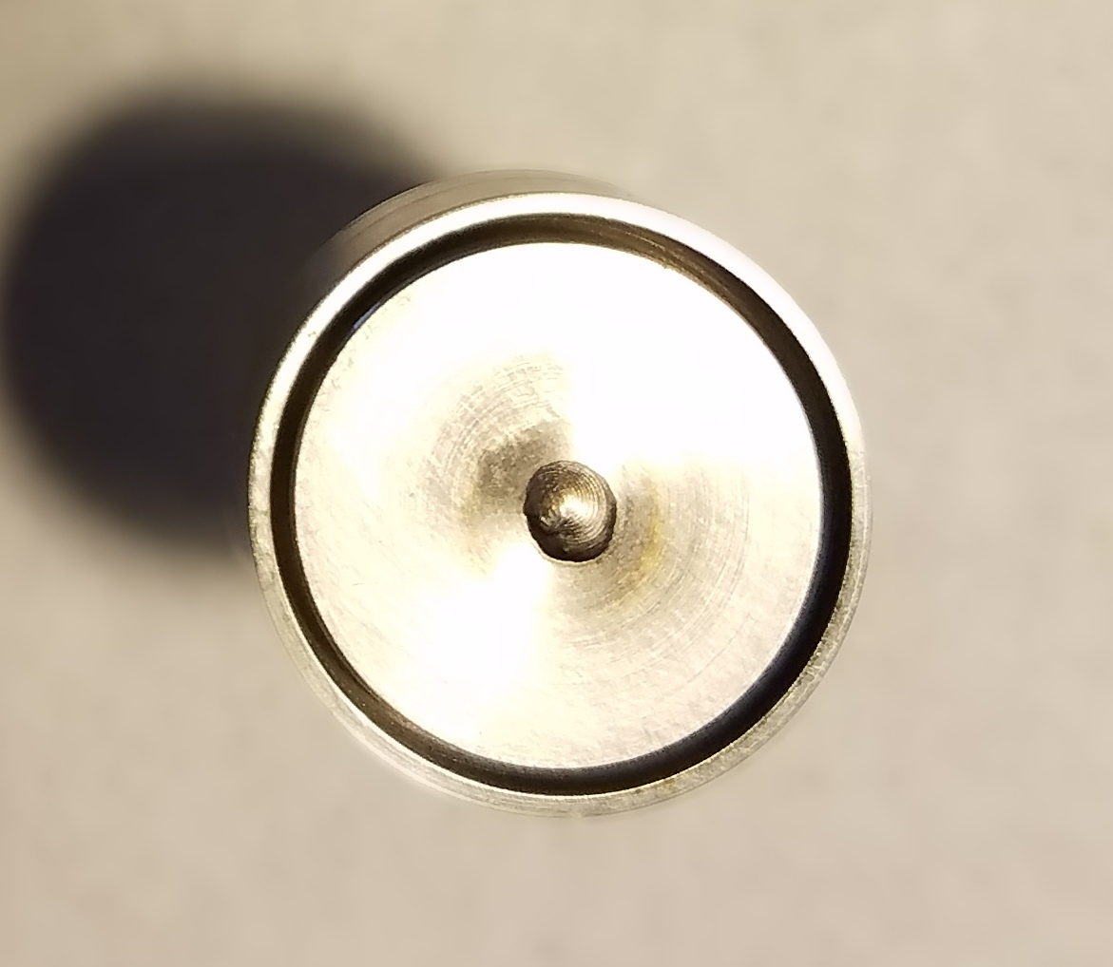
Photo of CBETA button

Proposed plan:

Measure a small sample set of the BPM assemblies using a coordinate measuring machine (CMM) to determine the typical mechanical offset errors. Use the CMM to measure the distance of each button from the center of the BPM. The actual process will likely include providing measurements from the flat exterior edges of the button chamber.

If typical errors are found to be smaller than xxx, then do not measure all units. If errors are found to be significant (greater than xxx), then assess the required cost vs. benefit of measuring each and every unit.

- Surveyed location of the BPM chamber

Proposed plan:

Provide a survey measurement of each and every BPM housing after installation in the final machine assembly. Use these measurements to determine the offsets of the mechanical center of each BPM.

- Stability of the BPM chamber and beam pipe due to temperature variations and incidental contact

Proposed plan:

Provide survey measurements (as detailed in item 2 above) of a small sample set (maybe 4) of BPM housings at different times over a few weeks and at different room temperatures. Use this information to determine the typical absolute position variations over time and as room temperature.

At this time, the proposed plan is to only identify the potential errors, not to provide corrections for this error.

- Electronic calibration and component mismatches

Options considered:

- Use a bench top pulser to generate a simulated beam signal connected to a 4-way splitter, with each splitter output connected to one of the V301 BPM module input signals. Calibrate using offset and gain coefficients to match all 4 signal measurements.
- Use a bench top pulser to generate a simulated beam signal into one buttons of the operational BPM and measure the induced signals on the other 3 buttons using the V301 module under calibration. Calibrate using offset and gain coefficients to match all 3 signal measurements. Then apply the simulated beam signal to one or more of the other buttons to measure and determine offset and gain coefficients to match all 4 button signal measurements.
- Connect one button signal to a 4-way splitter and connect each splitter output to the V301 BPM module under calibration. Use a button from the BPM that will be connected to the V301 module during normal operations, and use the operational button cables as they will be used during normal operations. Use beam to provide the generate the signal on the buttons that will be measured by the V301 module. Calibrate using offset and gain coefficients to match all 4 button signal measurements.
- Similar to c above, but use the CBETA button in the diagnostic line to calibrate each V301 module.
Discussion of options:

Using a bench top pulser as presented in option a would be the easiest to implement, but unfortunately the pulser does not provide a signal that accurately represents the beam signal. Filters, cables and other electronic components can have a response that is fairly significantly different using a pulser compared to using the actual beam signal. This could result in poor calibration results.

Option b provides similar issues to option a due to using a simulated signal, but would be useful to correct for capacitance differences between the buttons. However, mechanical offsets of the buttons within the BPM chamber could induce additional errors.

Option c is attractive because is would use one button from each of the operational BPMs after all hardware is installed. However, it would require having beam circulating through the entire machine prior to calibration. This would be very difficult.

Options d is very similar to option c but would use the same BPM in the diagnostic line to calibrate all of the V301 BPM modules along with the cable sets to be used with each. Each VME chassis could be preassembled with all of the operational modules installed, then temporarily located near the diagnostic line BPM for calibration. This would be tedious but will likely provide the most realistic option for reasonably calibrating the system.

Proposed plan:

Based on the discussions above, option d is the proposed plan. That is, calibrate each electronic module and operational set of button cables using beam in the diagnostic line, with connections as shown in the diagram below.

Well-matched high frequency 4-way splitter
Manufacturer: xxx
Model: xxx

V301 BPM module
BPM in diagnostic line

Install 50 ohm terminators on 3 unused button connections
Operational BPM cables must be used when V301 electronic module is calibrated with beam

The basic calibration procedure is as follows:
- Connect the V301 BPM module to be calibrated as shown in the above diagram. The button cables that will be used with the V301 module during operations must be connected so that they can be included as part of the calibration process. Experience has shown that cable attenuation and frequency response of cables varies. Label the cables as required to prevent mixing up between planes and between button inputs within the module.
- Enable beam.
- Adjust the analog to digital converter (ADC) clocks to sample the peak of each button signal.
- Execute the calibration routine (specifics to be determined) to determine the zero and gain settings for each of the 4 signal inputs of the V301 module.
- Record the calibration coefficients (specifics to be determined).

Perform the above procedure for every BPM hardware module.

This recommended plan does not address measurement errors due to button capacitance variations. It would be good to study the potential impact of capacitance variations on the position measurement errors, but at this time correction for this error is not planned.

Electronic component variations due to temperature changes is also not addressed in this plan. As above, it would be good to perform studies to better determine the impact on position errors; but again, correction for this error is not planned at this time.

The measured absolute offset errors in items 1 and 2 will be added together and entered as a value in the respective BPM EPICS IOC record for each BPM. The electronic calibration coefficients will be loaded in separate IOC records.

