Cornell High Energy Synchrotron Source
Doc#: SOP-COMP-001 | Procedure: CHESS Line Monitor GUI Startup |  |  | Prepared by: ZB
Rev.: 4 | Revision Date: 01/09/13 | Date Effective:  01/09/13 | Date Expires:  01/09/13 | Approved by: ZB

Purpose
To start the CHESS Line Monitor GUI after it has been closed.
Materials and Equipment Needed
- CHESS Beamline Control and Monitoring Computer
- Private Network connection
Safety
- Safety Issues: none
Procedure
NOTE: All steps in procedure should be performed on the Main Desktop for the Beamline Control computer. This monitor is located on the desk in CHESS operations and labeled “BEAMLINE STATUS AND CONTROL ONLY”.

- Click the “CSS” logo on the Start bar to start Control Systems Studio. (Fig. 1)
- Verify that the StartUp.opi file is open in the CSS Workspace. (Fig. 2)
- Press the large green [START GUI] button to execute the launch script. (Fig. 2)
- Beamline and device control windows will arrange themselves on monitors. (Fig. 3)
- If windows fail to load properly:
  - Close Control Systems Studio by clicking on a monitor and pressing <Alt + F4>. Repeat for each monitor.
  - Repeat steps 1-3.
  - If windows fail to load again, fill out a bug report form F-SFW-001 and report issues to computer group.
Figures

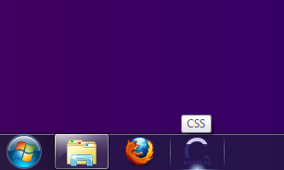
Fig. 1 – Click the CSS logo to launch Control Systems Studio

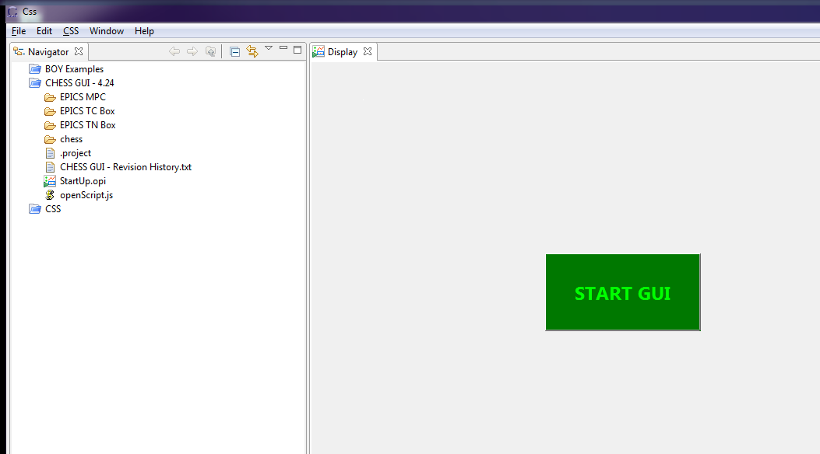

Fig. 2 – StartUp.opi is located in CHESS GUI - vNum/ directory and should be loaded automatically. Press START GUI button to launch the program.
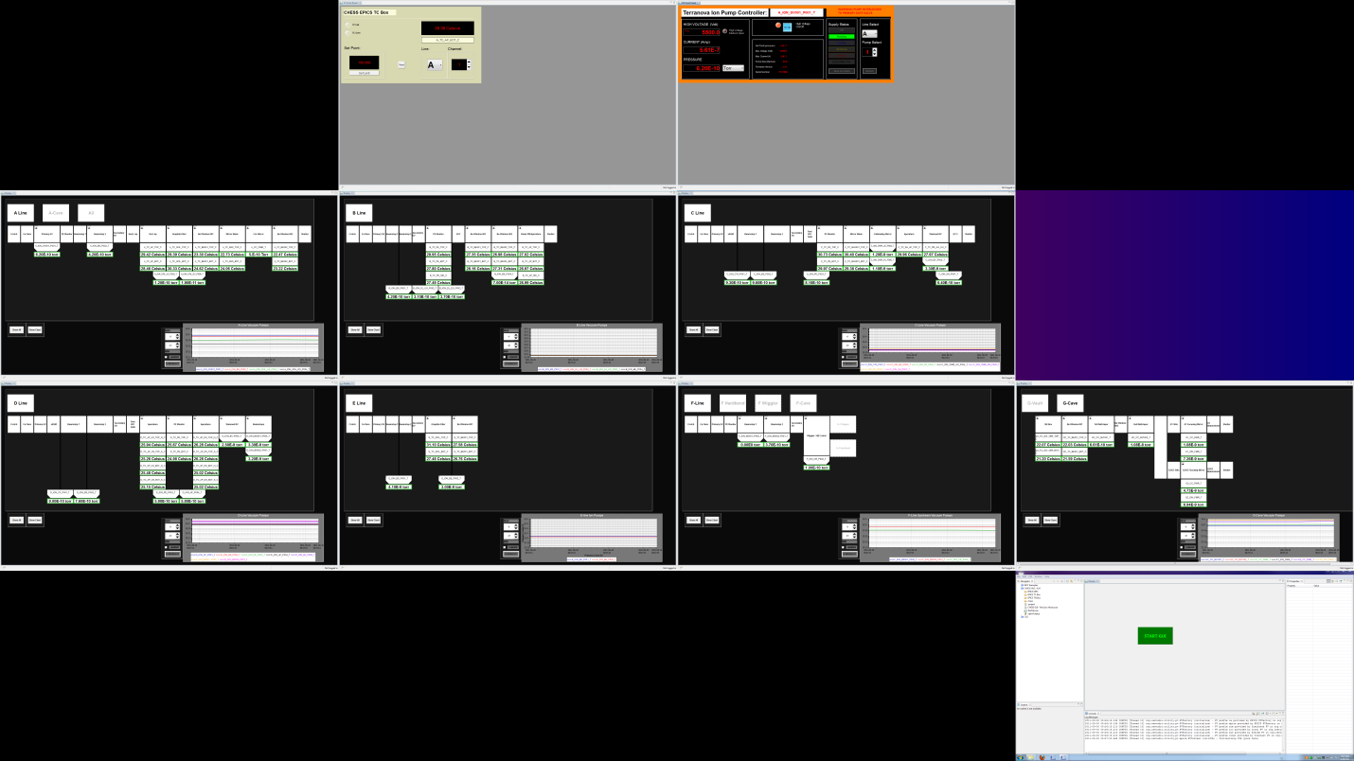
Fig. 3 – Beam Line Monitor Window arrangement

Revision History
Rev. 1 – Initial document (10/12/10 - ZB)
Rev. 2 – New Startup Procedure (06/14/11 - ZB)
Rev. 3 – New Startup Procedure. Removed steps 2a, 3, 4. Replaced Figures 1, 2, 3. Removed figures 4, 5. (09/30/11 - ZB)
Rev. 4 – Added revised title block and headers to document. Revised rev numbers starting from 1 (01/09/13 – ZB)

