Cornell High Energy Synchrotron Source
Doc#: SOP-COMP-002 | Procedure: Remote Access and File Transfer |  |  | Prepared by: ZB
Rev.: 1 | Revision Date: 06/02/12 | Date Effective:  06/02/12 | Date Expires:  06/02/13 | Approved by: ZB

Purpose
To establish remote access to a CHESS Linux terminal and transfer files.
Materials and Equipment Needed
- CHESS Private Network Control Computer (remote)
- CHESS Public Network Computer (local)
- SSH Client (Windows)
- SFTP Client (Windows)
Safety
- Safety Issues: none
Procedure
- Remote Access
  - Windows:
    - Double-click icon for ssh client to open (ex: SSH Secure Shell, putty).
    - Click [Quick Connect] to open connection dialog. (Fig. 1)
    - Type the hostname of the remote computer (ex: a1, ops1, roll) in Host Name entry box. (Fig. 2)
    - Type the username in User Name box.
    - Click [Connect] to connect to remote host username@remotehost.
    - Enter password when prompted.
    - Client terminal window is now an active terminal on the remote host.
    - Click [Disconnect] when finished to close the connection.

  - Linux:
    - Open new terminal.
    - Type <ssh username@remotehost.chess.cornell.edu>, where remotehost is the name of the remote computer (ex: a1, ops1, roll).
    - New line in terminal window should now show the remote host information.
    - Type <exit> when finished to close the connection.

- File Transfer
  - Windows
    - Double-click icon for ssh client to open (ex: SSH Secure File Transfer).
    - Click [Quick Connect] to open connection dialog. (Fig. 3)
    - Type the hostname of the remote computer (ex: a1, ops1, roll) in Host Name entry box. (Fig. 2)
    - Type the username in User Name box.
    - Click [Connect] to connect to remote host username@remotehost.
    - Enter password when prompted.
    - File Browser on left shows local directory. File Browser on right shows remote directory.
    - Drag files between browsers to transfer files.
    - Click [Disconnect] when finished to close the connection.
    - New folders can be created on remote or local host by clicking the New Folder button located above respective File Browser.
    - Directories can be refreshed by clicking the Refresh button.
    - Return to the home directory by clicking the Home button.

  - Linux
    - Open a new terminal.
    - Type <sftp username@remotehost.chess.cornell.edu>, where remotehost is the name of the remote computer (ex: a1, ops1, roll).
WARNING: File transfer from command line does NOT prompt before overwriting files.

    - Type <get remote_file local_file> to transfer a source file from the remote computer to the destination file on the local computer.
      - remote/local_file can either be the file name in the working directory, or /path/filename if file is located outside of working directory.
      - Type <pwd> to print working directory.
      - Type <ls> to show which files are available in working directory.
    - Type <put local_file remote_file> to transfer a source file from the local computer to the destination file on the remote computer.
      - remote/local_file can either be the file name in the working directory, or /path/filename if file is located outside of working directory.
      - Type <pwd> to print working directory.
      - Type <ls> to show which files are available in working directory.
    - NOTE: if second argument is left out of get/put commands, the file name will be the same.
    - Type <exit> when finished to close the connection.

Figures
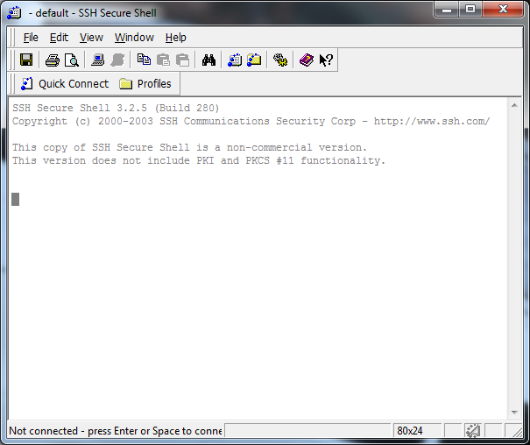
Figure 1 – SSH Secure Shell window

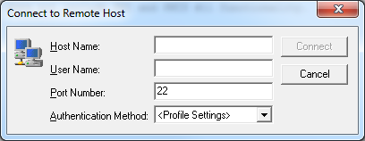
Figure 2 – Hostname/username Window
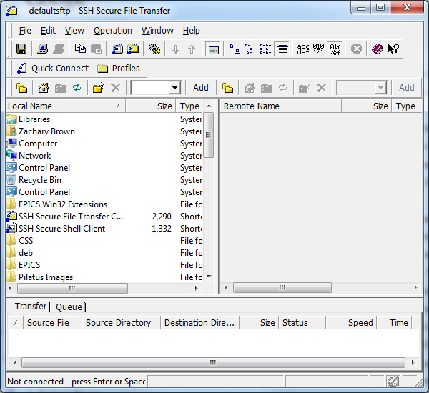
Figure3 – SSH Secure File Transfer window (with Directory controls highlighted)

References
None.
Revision History
Rev. 1 – Initial document (06/02/12 - ZB)

