Cornell High Energy Synchrotron Source
Doc#: SOP-COMP-003 | Procedure: Roll Station Start-up |  |  | Prepared by: GT
Rev.: 1 | Revision Date: 02/19/13 | Date Effective:  02/19/13 | Date Expires:  02/19/14 | Approved by: ZB

Purpose
To boot-up a CHESS roll station.
Materials and Equipment Needed
- CHESS Roll Station
- CHESS Private Network Switch
- CHESS Public Network Switch
- Private network cable (red)
- Public network cable (white)
Safety
- No safety issues
Procedure
- Plug roll station power strip cable into power outlet.
- Connect MDCP to CHESS Private Network using private (red) network cable. (Fig. 1a)
- Turn on MDCP by using the power switch on the front of the unit.
- Connect PC to CHESS Public Network using public (white) network cable. (Fig. 1b)
- Open right front hatch on PC, press power switch. (Fig. 2)
- Once PC has booted, type in ‘00000000’ when prompted for password, press [ENTER].
- Log in as specuser:
  - username: specuser
  - password: CThrooMe
- Open konsole, type spec to launch SPEC.

Figures
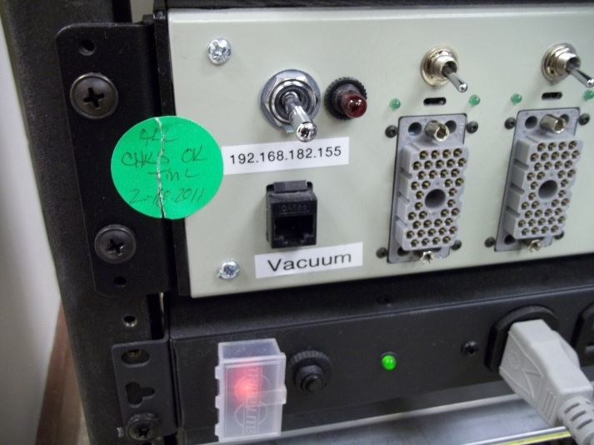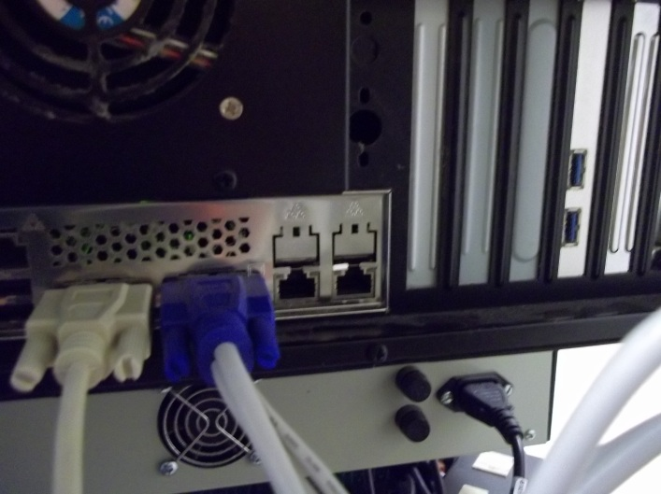
Figure 1a: MDCP port for private network cable Figure 1b: PC port for public network cable
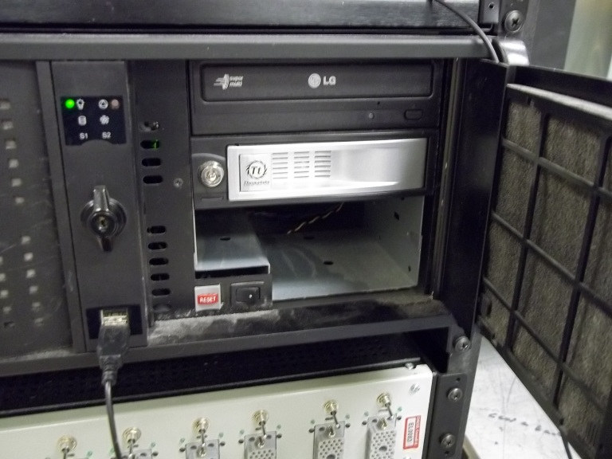
Figure 2: PC Power switch (circled)
References
none
Revision History
Rev. 1 – Initial document (02/18/13 - GT)

