Cornell High Energy Synchrotron Source
Doc#: SOP-COMP-004 | Procedure: CHESS DAQ Folder Access |  |  | Prepared by: ZB
Rev.: 1 | Revision Date:  11/10/15 | Date Effective:  11/10/15 | Date Expires:  11/10/16 | Approved by: ZB

Purpose
To provide access to CHESS DAQ folders on a user computer, CHESS Detector Computer, or CHESS Station computer.
Materials and Equipment Needed
- Computer:
  - User PC
  - Detector Computer
  - CHESS Station Computer
- Network Connection
  - CHESS Public (User)
  - CHESS DAQ (Detector or Station Computer)
- CLASSE Credentials
Safety
- Safety Issues: none
Procedure
- User PC
  - Connect CHESS Public network cable to User PC.
  - Open My Computer.
  - Click “Map Network Drive” in Menu Bar. (Fig. 1)
  - Map CHESS DAQ RAW drive (Fig. 2):
    - Drive: Z:\ or first available.
    - Folder: \\chesssamba.classe.cornell.edu\raw\current\<beamline>
    - Reconnect at logon:
    - Connect using different credentials:
  - Login (Fig. 3):
    - Username: CLASSE\username
    - Password: <CLASSE password>
    - Remember my credentials:
  - Repeat steps 1.2.1 – 1.3.3 for CHESS AUX if needed.
    - Substitute \\chesssamba.classe.cornell.edu\aux for step 1.2.4
- Detector Computers
  - Linux
    - Connect CHESS DAQ network cable to Detector Computer.
    - Move to /mnt/ directory:
      - Open new Terminal.
      - Type cd /mnt/ to move to the /mnt/ directory.
    - Mount CHESS DAQ drive:
      - There should be a folder named creds and a script named mount_currentdaq in the /mnt/ folder. To automate the mounting process, the CLASSE login credentials are stored in files inside the creds folder (root access required to view or edit).
      - Type ./mount_currentdaq <beamline>.
      - Type cd currentdaq to verify contents.
  - Windows
    - Connect CHESS DAQ network cable to Detector Computer.
    - Open My Computer.
    - Map CHESS DAQ drive (Fig. 2):
      - Drive: Z:\ or first available.
      - Folder: \\chesssamba\daq\current\<beamline>
      - Reconnect at logon:
      - Connect using different credentials:
    - Login:
      - Username: CLASSE\chess_<station> (ex: chess_f2)
      - Password: <Station Computer CLASSE password>
      - Remember my credentials:
- CHESS Station Computers
  - Linux
    - CHESS Station computers use an automount system to mount CHESS DAQ and RAW.
      - Located in /mnt/currentdaq and /mnt/raw
      - Configuration files for the automount are /etc/auto.master and /etc/auto.smb. They reference a credentials file located in the root directory that stores the CLASSE login credentials for that station (root access required to view or edit).
      - If the DAQ or RAW folders are inaccessible, contact CHESS computer group for support.

Figures
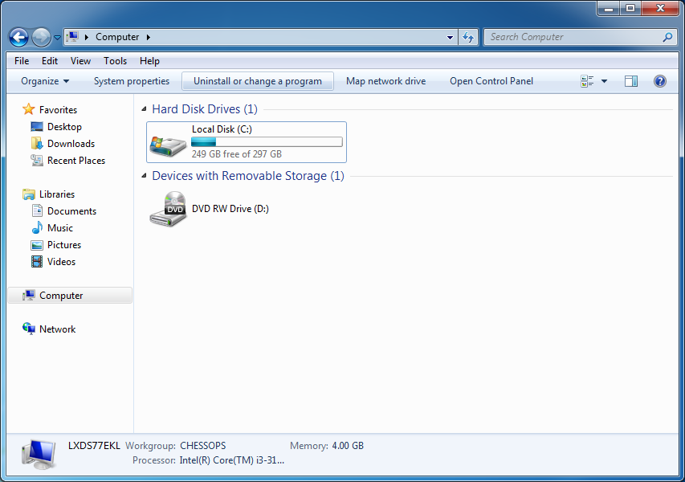
Figure 1 – Map Network Drive from My Computer

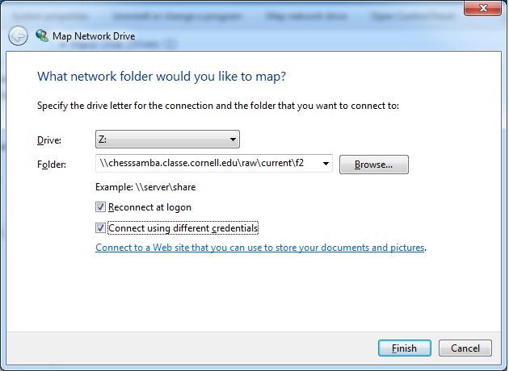
Figure 2 – Map Network Drive Information
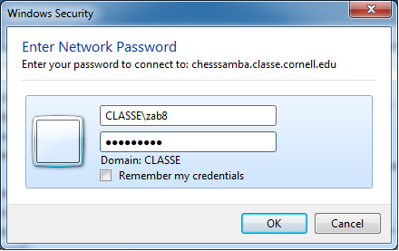
Figure3 – CLASSE credentials for DAQ Access

References
None.
Revision History
Rev. 1 – Initial document (11/10/15 - ZB)

