Cornell High Energy Synchrotron Source
Doc#: SOP-COMP-005 | Procedure: CHESS DAQ Data Transfer |  |  | Prepared by: ZB
Rev.: 2 | Revision Date:  01/29/16 | Date Effective:  01/29/16 | Date Expires:  01/29/17 | Approved by: ZB

Purpose
To transfer user data from CHESS DAQ storage to user data storage system.
Materials and Equipment Needed
- Computer:
  - Linux Kiosk (Ops Area/Reception)
- Network Connection
  - CLASSE
- CLASSE Credentials
Safety
- Safety Issues: none
Procedure
- Connect user’s portable storage drive.
- Press any key to bring up the kiosk login prompt
- Login:
  - Username: <CLASSE username>
  - Password: <CLASSE password>
CHESS DAQ Data is located at: /nfs/chess/raw/current/<beamline>/<userdatafolder>
It can be accessed via Desktop GUI or Commandline

- Transfer Files via Desktop GUI:
  - Double-click CLASSE_shortcuts Folder on left side of Desktop. (Fig. 1)
  - Double-click chess_raw folder in new window. (Fig. 2)
  - Navigate to data folder by double-clicking following folders:
    - <beamline>
    - <user data folder>
  - Right click folder, select ‘Copy’.
  - Click User’s portable storage drive under “Devices” in Navigation Pane.
  - Right click, select ‘Paste’.

- Transfer Files via Command Line
  - Right click on desktop, select Open Terminal. (Fig. 3)
  - Type: cp –vr /nfs/chess/raw/current/<beamline>/<userdatafolder> /run/media/<username>/<drive>/

Figures
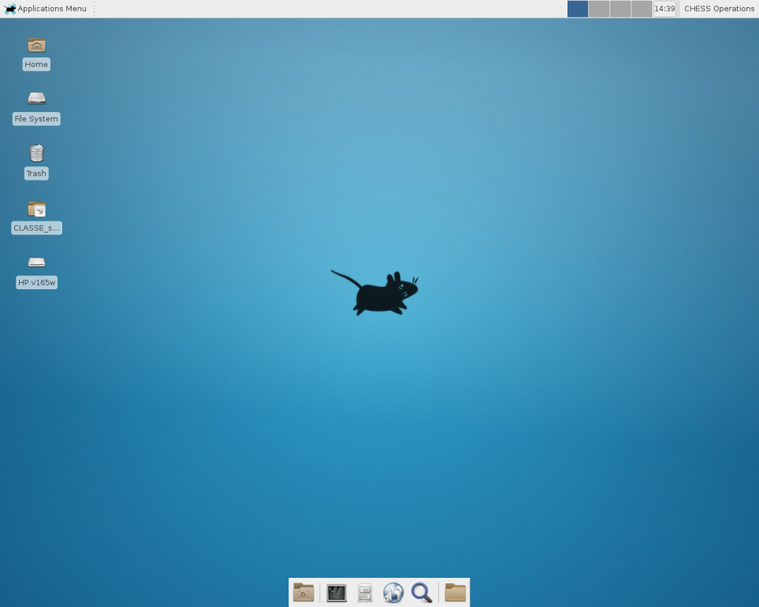
Figure 1 – CLASSE_shortcuts

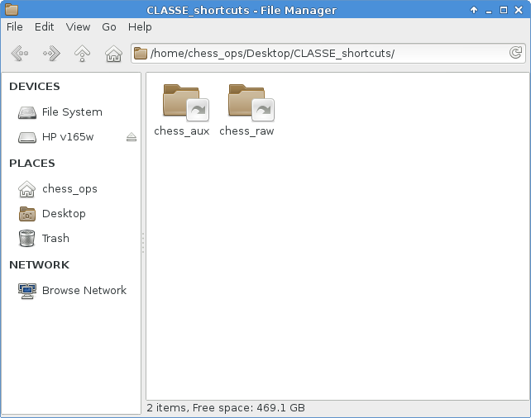
Figure 2 – Beamline data in /nfs/chess/raw/<beamline> Folder
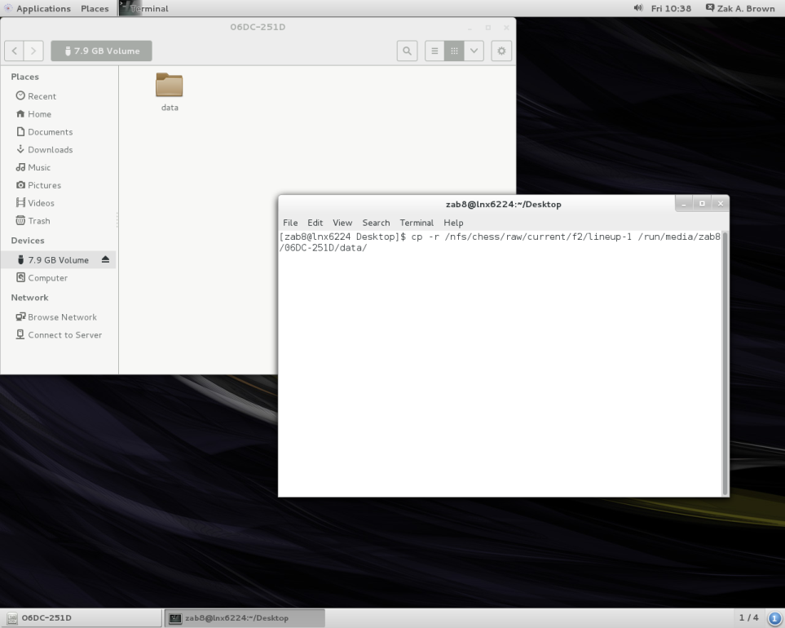
Figure3 – Command line cp command to copy data

References
None.
Revision History
Rev. 1 – Initial document (12/04/15- ZB)
Rev.2 – Edits for new kiosk mode Linux Machine (01/29/16 – ZB)

