Cornell High Energy Synchrotron Source
Doc#: SOP-DOC-001 | Procedure: CHESS Document Control Approval and Release |  |  | Prepared by: ZB
Rev.: 6 | Date Revised: 06/16/13 | Date Effective:  06/16/13 | Date Expires:  06/16/14 | Approved by: ZB

Purpose
To submit and approve a new document that conforms to CHESS documentation control standards.

Materials and Equipment Needed
- Document for approval
- Completed Document Change Request Form (F-DOC-001)
Safety
- Safety Issues: none
Procedure
See Figure 1 for flow diagram of the main steps of the following procedure

- Submission
  - Create new document or edit existing document
  - Document shall be written and categorized in accordance with REF-DOC-001 with a placeholder Document ID #.
  - Complete Document Change Request Form (F-DOC-001)
    - Note changes made when editing existing documents.
  - Submit electronic copies of new/revised document and completed F-DOC-001 via email to party responsible for approval. See Table 1 for list of responsible parties.
- Review
  - Team leaders shall be responsible for approval of documents pertaining to their area.
  - New Documents:
    - Verify integrity of information in document.
    - Verify that document contains required Document Control information and sub-sections in accordance with REF-DOC-001.
    - Verify References made within the document are accurate.
    - Verify Revision history (Date, name).
      - New documents should be Revision 1 and described as “Initial Document”.
    - Submit completed F-DOC-001 and new document to Document Control staff.
  - Revised Documents:
    - Using the submitted F-DOC-001, verify the integrity of the edits made.
    - Examine the document to verify all changes made were listed in submitted form.
    - Verify References made within the document are accurate.
    - Verify Revision history (Revisions, Date, Name).
    - Submit completed F-DOC-001 and new document to Document Control staff.
- Release
  - Document Control Staff shall be responsible for conformance and final release of documents.
  - New Documents:
    - Assign document next sequential Document ID# by changing file name and Doc# fields in document.
    - Upload new document into web system:
      - Open Google Drive CHESS_DOC folder.
      - Drag local document into window to upload the document.
        - NOTE: Do NOT format the document for Google Docs.
      - Select the newly added document and click [“Share Settings…”] button to change sharing settings.
      - Change “Who has access:” to “Anyone who has the link can view”.
      - Copy the “Link to share:” to the clipboard.
    - Update Document Control Index.
      - For Manuals: Click MANUAL_INDEX Google Spreadsheet to open the sheet for editing.
      - For All Other Documents: Click DOC_INDEX Google Spreadsheet to open the sheet for editing.
      - Type =hyperlink(“COPIED_LINK”, “DOC_ID”) in “Document ID” column.
        - Ex: =hyperlink("https://docs.google.com/...", "SOP-DOC-001")
      - Drag entries from “Type” and “Designation” columns down to current row to fill in “Type” and “Designation” automatically.
      - Add Document Title to “Document Title” column.
      - Add Revision number (1) to “Revision” column.
      - Add Revision Date to “Revision Date” column.
      - Add Verified Date to "Verified Date" column.
      - Add Author to “Author” column.
      - Click newly added hyperlink under “Document ID” to verify link to correct document.
    - Post update to CHESS WebBoard in Documentation conference.

  - Revisions:
    - Rename and archive existing version in OBS- directory:
      - Select existing document and click [“More…”] and select “Rename”.
      - Change Document Name to OBS-DOC_IDvX, where X is the revision number.
      - Drag renamed file into appropriate OBS- directory.
    - Upload revised document into web system:
      - Follow steps 3.2.2.1 – 3.2.2.5.
    - Update Document Control Index.
      - Follow steps 3.2.3.1 – 3.2.3.8.
    - Post update to CHESS WebBoard in Documentation conference.

Figures
Department | Doc ID Designation | Responsible Party
Beam Position Monitoring | BPM | Revesz
Computer | COMP | Sorenson
CESR-TA | CTA | Lyndaker
Detectors | DET | Chamberlain
Documentation | DOC | Brown
Electronics | ELEC | Chamberlain/Edwards
MacCHESS | MAC | Smith
Motors | MOT | Edwards
Operations | OPS | Conolly
Safety | SAF | Richter
Vacuum | VAC | Seeley
Table 1 – Document Designations and Responsible Parties

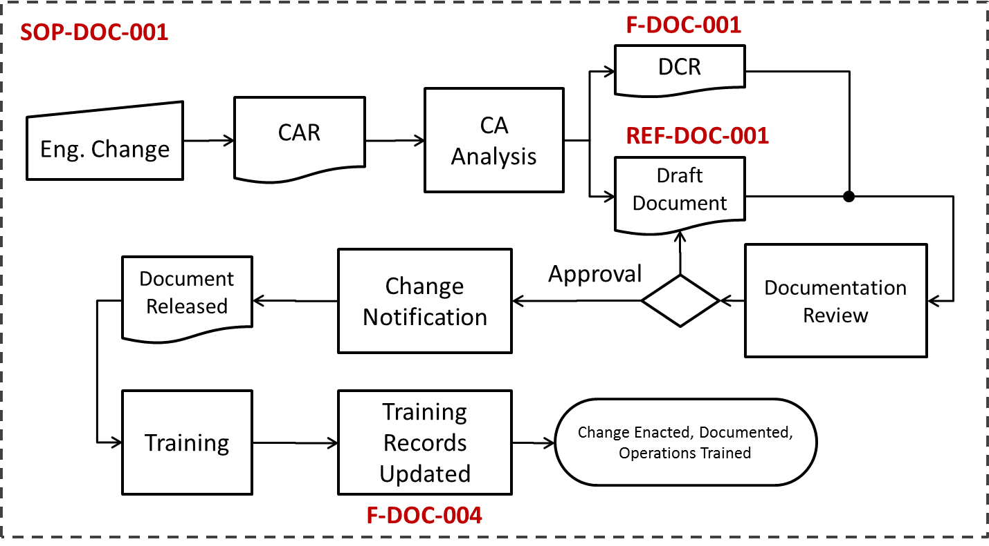
Figure 1- Flow diagram for Approval and Release Process

References
F-DOC-001. Document Change Request
REF-DOC-001. CHESS Document Control Standards
Revision History
Rev. 1 – Initial document (05/24/12 - ZB)
Rev. 2 – Detailed Google Docs upload process 3.2.2, 3.2.3, 3.3.1, 3.3.3 (07/30/12 - ZB)
Rev. 3 – Added watermark header. Added page numbers. Revised 3.2.2.4 for accuracy. Clarification on entering hyperlink to Document Index and added example 3.2.3.2.1. (09/27/12 – ZB)
Rev. 4 - Added flow chart for overview of approval and release procedure. (11/15/12 - ZB)
Rev. 5 – Added instruction for listing uploaded documents vs. uploaded manuals. (05/17/13 – ZB)
Rev. 6 - Added Verification Date references to 3.2.3.9 & 3.3.3.1. (06/16/13 - ZB)

