ILC Damping Rings Component/Subsystem Specification

Part I – Classification Information
Component Description: | Dipole magnet power cable
Component Location (beamline): | EDR, PDR I, PDR II | Lattice Version: |  | OCS6, 2006-06-30
Document Number: | EDR-MAG-cbl-001 |  | Date: | 2006-08-03
Prepared by: | Andy Wolski (Cockcroft) |  | email: | a.wolski@dl.ac.uk
Technical/Global System: | Magnets
Technical/Global System Contact: | John Tompkins (FNAL) |  | email: | jct@fnal.gov
DR Area System Contact: | Mike Zisman (LBNL) |  | email: | mszisman@lbl.gov

Part II – Main Parameters
Parameter | Value | Reference
Quantity per beamline | 22.6 km | [1]
Conductor | Copper
Electrical conductivity | 60×10⁻⁶ Ω⁻¹m⁻¹
Density | 8920 kg/m³
Conductor cost | Public version: no costs shown | [2]
Cable resistance | 0.0433 Ω/km
Cable diameter | 22 mm
Cable mass | 3.4 kg/m
Maximum current | 520 A | [3]
Voltage drop at maximum current | 22.5 V/km
Unit cost per metre | Public version: no costs shown

ILC Damping Rings Component Specification

Document Number: | EDR-MAG-cbl-001 | Date: | 2006-08-03

Part III – Other Parameters, Information, and Drawings
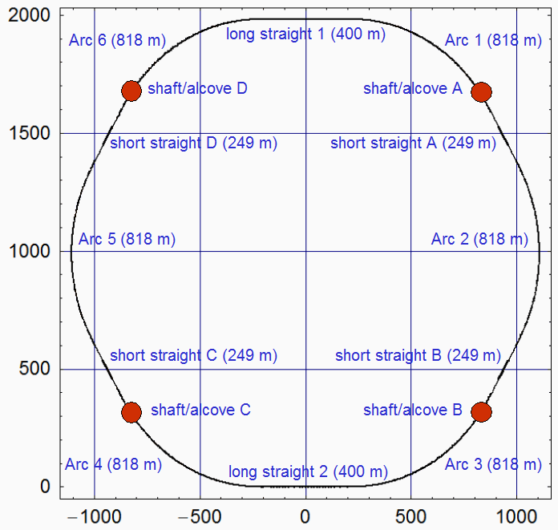

Figure 1: Schematic Layout

ILC Damping Rings Component Specification

Document Number: | EDR-MAG-cbl-001 | Date: | 2006-08-03

Part III – Other Parameters, Information, and Drawings (continued)

Table1: Dipole cables and cable lengths (see Figure 1).
Cable | Region | Dipoles | Length
1 | Arc 1 | 19 × 6 m | 1636 m
2 | Short Straight A & Arc 2 | 19 × 6 m | 2134 m
3 | Arc 3 | 19 × 6 m | 1636 m
4 | Arc 4 | 19 × 6 m | 1636 m
5 | Short Straight C & Arc 5 | 19 × 6 m | 2134 m
6 | Arc 6 | 19 × 6 m | 1636 m
7 | Arcs 1,2,3 & Short Straights A,B | 6 × 3 m | 5904 m
8 | Arcs 4,5,6 & Short Straights C,D | 6 × 3 m | 5904 m

Part IV – References
[1] See Table 1.

[2] London Metal Exchange: http://www.lme.co.uk

[3] EDR-MAG-dip-001

