Notes and Conclusion from the ILC Damping Rings WebEx Meeting to Choose the Baseline Lattice for the Remainder of the Technical Design Phase

Meeting Time: Tuesday, June 28, 2011, 9AM US EDT
Attendees:
Wang Dou (IHEP
Jie Gao (IHEP)
Guoxing Xia
Susanna Guiducci (INFN-LNF)
Gerry Dugan (Cornell)
David Rubin (Cornell)
Mark Palmer (Cornell)

Presentations and Summaries
Introduction to the process (M. Palmer)
DTC Presentation (D. Rubin)
DMC 10Hz Presentation (Wang Dou)
Status Report on DSB (S. Guiducci)

Comments
- DTC lattice
  - Has acceptable dynamic aperture for the 5 Hz Low P configuration as well as the 10 Hz configuration (note that wiggler and RF differ in the 2 configurations). Dynamic aperture simulations utilize an ideal non-linear wiggler model
  - Momentum compaction is 3.3×10⁻⁴ which provides better margin for the onset of instabilities
  - The configuration is compatible with 12 RF cavities over the range of low power, high power, and 10Hz operating configurations
  - The lattice utilizes the new “standard” 710m straight which is now the baseline being used by the CFS group
- DMC4 Lattice
  - This update is specifically to look at the possibility of operating the DMC lattice for the 10Hz option
  - This design utilizes a 610m straight
  - 90 degree phase advance option:
    - Momentum compaction is 2.1×10⁻⁴ which should provide acceptable margin for the onset of instabilities
    - RF voltage required is 14.1MV
  - 75 degree phase advance option:
    - Momentum compaction is 3.3×10⁻⁴ which provides better margin for the onset of instabilities
    - RF voltage required is 20MV
  - No dynamic aperture checks have been completed yet for this configuration
- DSB4 Lattice
  - Utilizes approximately the “standard” straight
  - Momentum compaction is is 1.7×10⁻⁴ which is in the range that we specified to provide acceptable margin for the onset of instabilities
  - Dynamic aperture has been checked with out wigglers for the 5Hz configuration and appears OK. A check with a non-linear wiggler model is desired.
  - Overall needs some more work and limited design time will be available in the immediate future

Baseline Decision
The over-riding element in the discussion of the baseline selection was the need for a complete design that could be provided to the simulators to confirm its properties and for which a preliminary costing could be carried out. Thus a detailed item-by-item comparative evaluation of each of the 3 lattice designs was not conducted at this meeting. Under the present circumstances, the issue of completeness led to the DTC being proposed and then selected as the official baseline lattice for the TDP-II. While a significant amount of work and refinement is needed, this will be the basis for our efforts for the remainder of the year. A proposal was made to have both Cornell and IHEP resources continue the development. A partial comparison of parameters of the 3 lattices is shown in the table below.

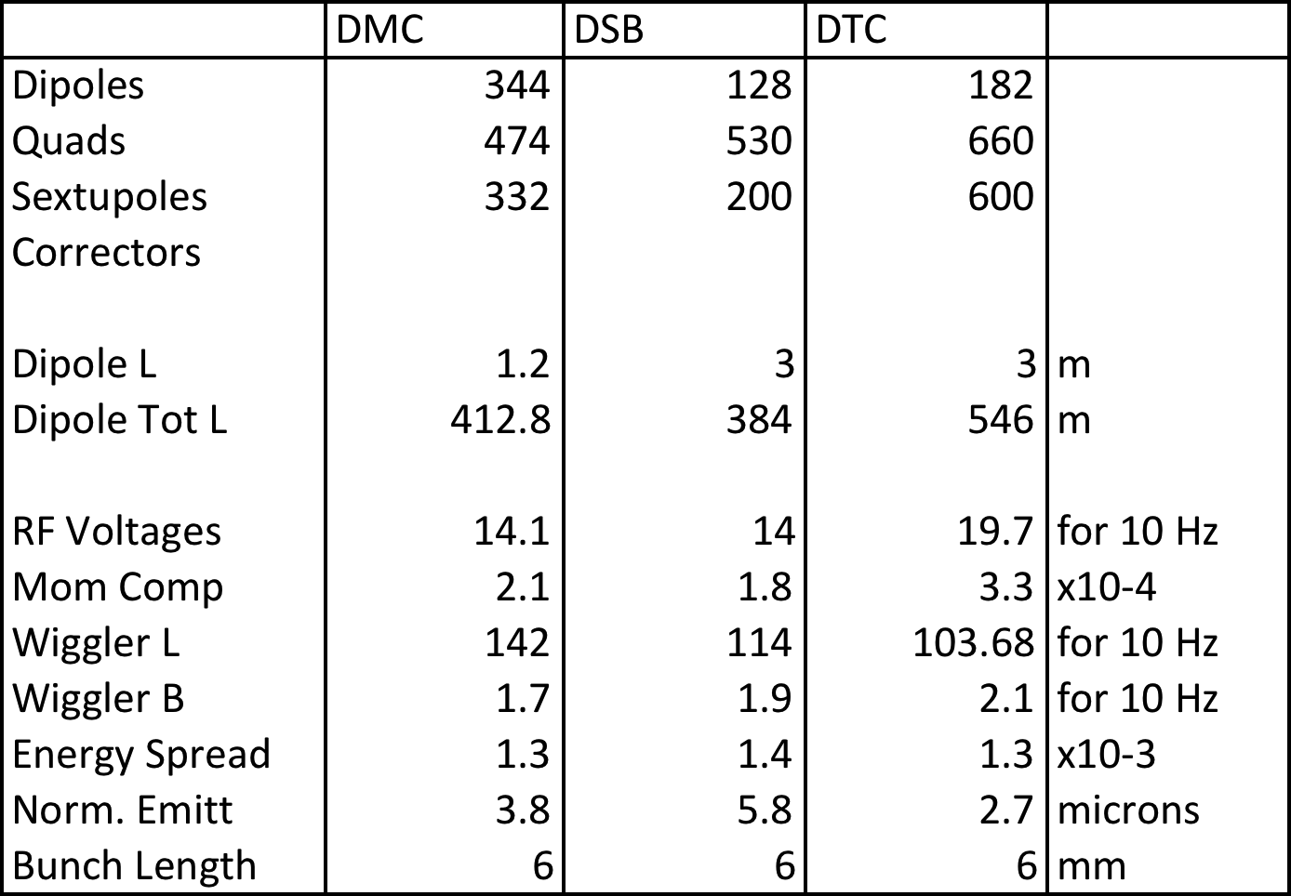

Other Comments
It was proposed to hold our next group meeting during the first week of August. A meeting within roughly one month is deemed highly desirable in order to provide supporting information to the physics simulations as well as ensure that a plan for further lattice refinements is efficiently implemented.

